**Creating Child account in AWS Console.**

**Step :1 -** Login to the console and navigate to accounts.

**Step :2 –** Click on **My Organisation**

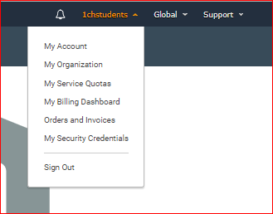

**Step 3: -** Click on Create Organisation, under which you can add/invite users.

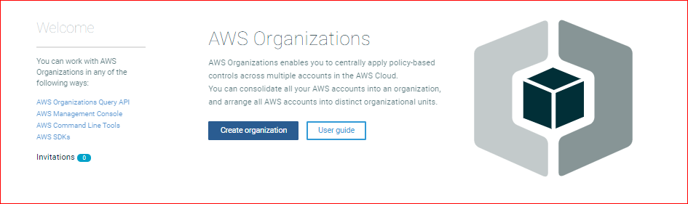

**Note: 🡪 Organisational Accounts holds below mentioned Privileges, Click on Create Organisation.**

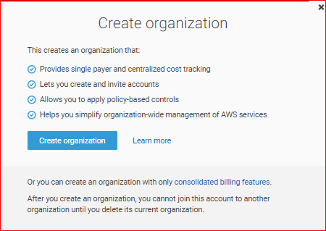

**Step 4: -** After Creating an Organisation you can see the below screen. As organisation is created.

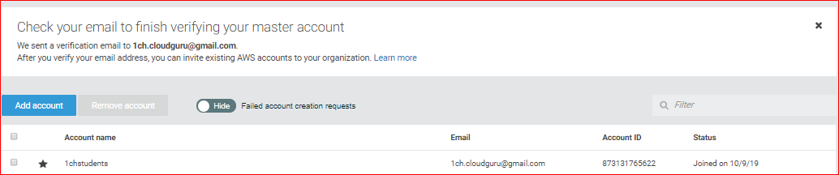

**Step 5: - Click on add account**. (Which server as a child account)

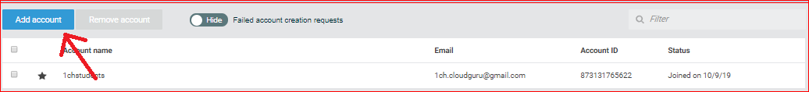

**Step 6: -** After clicking on add account, it displays a screen as below. Choose create account.

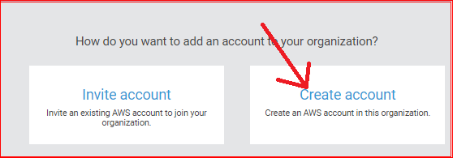

**How to Create an Account.**

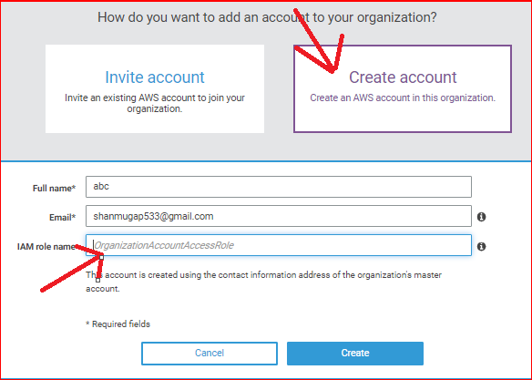

**NOTE: Create a IAM role for newly added users in master account and grant the required permissions.**

**Step 7: -** Required account has been created.

